BANK LOAN ANALYSIS POWER BI DASHBOARD –
This project involves the analysis of bank loan data using SQL queries and Power BI to provide a comprehensive overview of key loan metrics. It includes tracking total loan applications, funded amounts, payments received, and average interest rates. Month-to-date (MTD) and previous month-to-date (PMTD) comparisons are used to monitor performance trends over time. The analysis also breaks down loans by debt-to-income (DTI) ratio, loan status (good vs. bad loans), and regional distribution by state.
Additionally, loan data is categorized based on loan term, employment length, loan purpose, and home ownership status, with the option to further classify by loan grade and state. By visualizing this data in Power BI, the project provides actionable insights into loan performance, helping stakeholders make informed decisions and assess risk effectively.
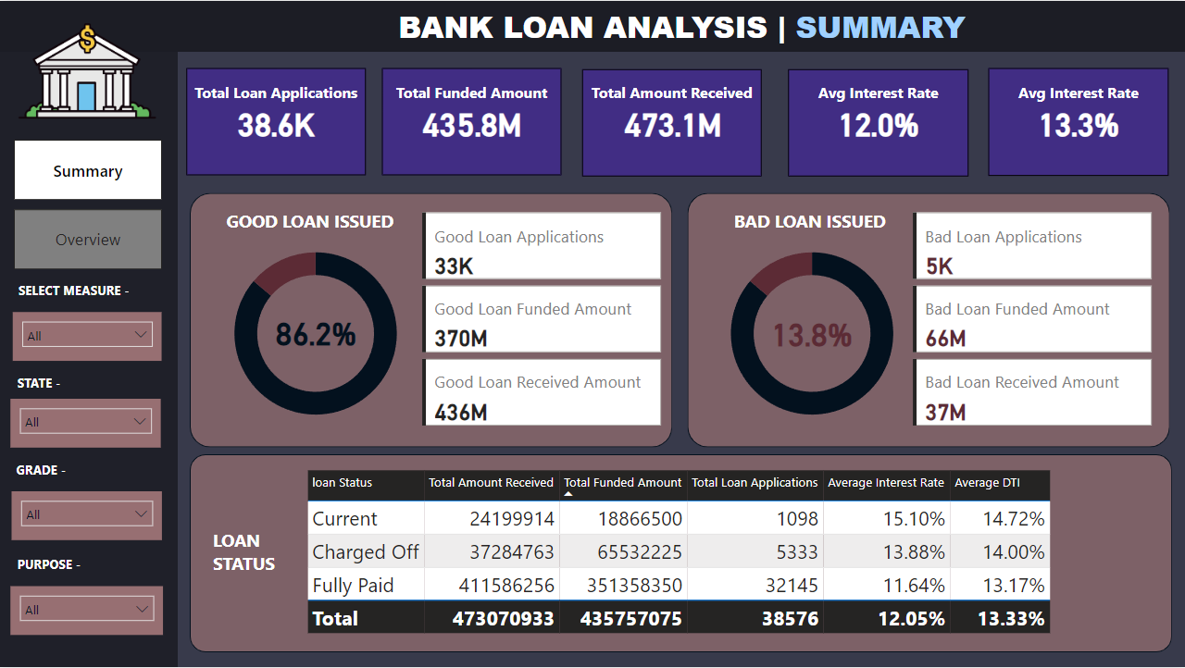
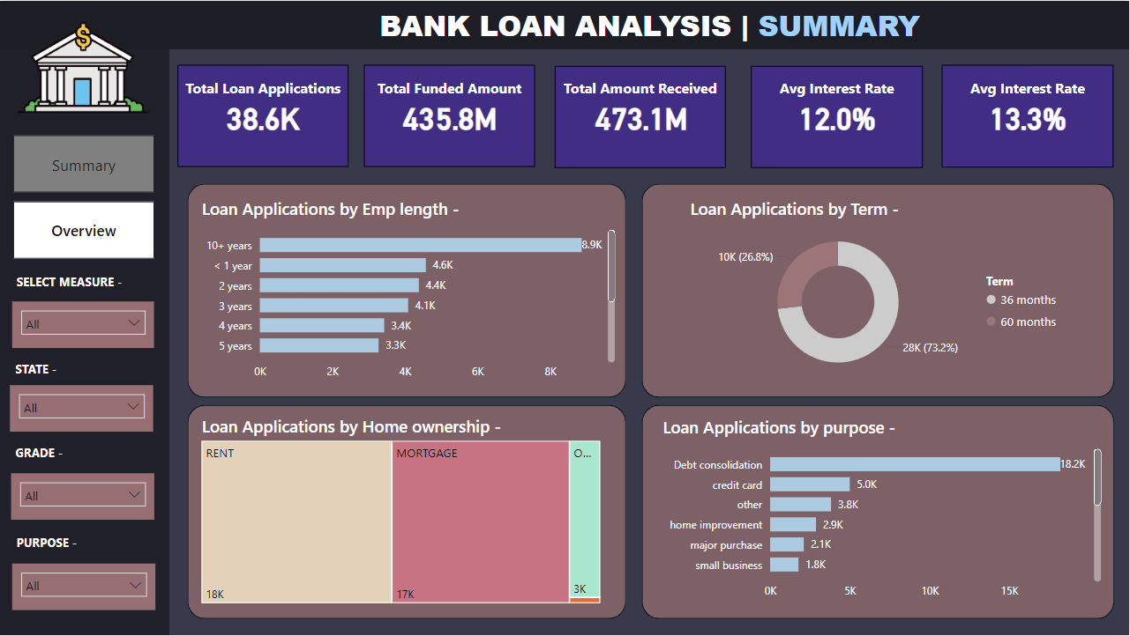
BANK LOAN ANALYSIS SQL QUERIES –

DASHBOARD 1 (SUMMARY) –

TOTAL LOAN APPLICATIONS -
Select COUNT(id) AS Total_Loan_Applications FROM bank_loan_db.bank_loan_data;
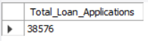
MTD LOAN APPLICATIONS –
Select COUNT(id) AS MTD_Loan_Applications FROM bank_loan_db.bank_loan_data
WHERE MONTH(issue_date)= 12 AND YEAR(issue_date)= 2021
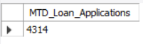
PMTD LOAN APPLICATIONS – (For month to month Track = (MTD-PMTD/PMTD)
Select COUNT(id) AS PMTD_Loan_Applications FROM bank_loan_db.bank_loan_data
WHERE MONTH(issue_date)= 11 AND YEAR(issue_date)= 2021
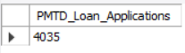
TOTAL FUNDED AMOUNT -
Select SUM(loan_amount) AS Total_Funded_Amount FROM bank_loan_db.bank_loan_data
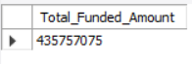
TOTAL FUNDED AMOUNT (in Dec) -
Select SUM(loan_amount) AS MTD_Total_Funded_Amount FROM bank_loan_db.bank_loan_data
WHERE MONTH(issue_date)= 12 AND YEAR(issue_date)= 2021
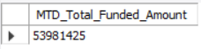
TOTAL FUNDED AMOUNT (in Nov) -
Select SUM(loan_amount) AS PMTD_Total_Funded_Amount FROM bank_loan_db.bank_loan_data
WHERE MONTH(issue_date)= 11 AND YEAR(issue_date)= 2021
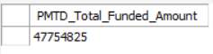
TOTAL AMOUNT RECEIVED -
Select SUM(total_payment) AS Total_Amount_received FROM bank_loan_db.bank_loan_data;
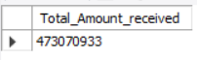
TOTAL AMOUNT RECEIVED (in Dec) -
Select SUM(total_payment) AS MTD_Total_Amount_received FROM bank_loan_db.bank_loan_data
WHERE MONTH(issue_date)= 12 AND YEAR(issue_date)= 2021
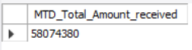
TOTAL AMOUNT RECEIVED (in Nov) -
Select SUM(total_payment) AS PMTD_Total_Amount_received FROM bank_loan_db.bank_loan_data
WHERE MONTH(issue_date)= 11 AND YEAR(issue_date)= 2021
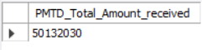
AVERAGE INT RATE –
Select AVG(int_rate) * 100 AS Avg_Interest_Rate FROM bank_loan_db.bank_loan_data
ROUNDING AVERAGE INT RATE -
Select ROUND(AVG(int_rate),4) * 100 AS Avg_Interest_Rate FROM bank_loan_db.bank_loan_data
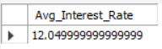
AVERAGE INT RATE (in Dec) -
Select ROUND(AVG(int_rate),4) * 100 AS MTD_Avg_Interest_Rate FROM bank_loan_db.bank_loan_data
WHERE MONTH(issue_date)= 12 AND YEAR(issue_date)= 2021
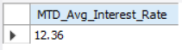
AVERAGE INT RATE (in Nov) -
Select ROUND(AVG(int_rate),4) * 100 AS PMTD_Avg_Interest_Rate FROM bank_loan_db.bank_loan_data
WHERE MONTH(issue_date)= 11 AND YEAR(issue_date)= 2021
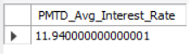
ROUNDING AVERAGE DTI -
Select ROUND(AVG(dti),4) * 100 AS Avg_DTI FROM bank_loan_db.bank_loan_data
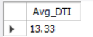
AVERAGE DTI (in Dec) -
Select ROUND(AVG(dti),4) * 100 AS MTD_Avg_DTI FROM bank_loan_db.bank_loan_data
WHERE MONTH(issue_date)= 12 AND YEAR(issue_date)= 2021
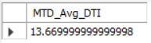
AVERAGE DTI (in Nov) -
Select ROUND(AVG(dti),4) * 100 AS PMTD_Avg_DTI FROM bank_loan_db.bank_loan_data
WHERE MONTH(issue_date)= 11 AND YEAR(issue_date)= 2021
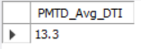
GOOD LOAN PERCENTAGE (Fully Paid, Loan status) –
SELECT (COUNT(CASE WHEN loan_status = "Fully Paid" OR loan_status ="Current" THEN id END)*100)/COUNT(id) AS Good_Loan_percentage From bank_loan_db.bank_loan_data;
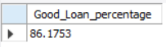
GOOD LOAN APPLICATIONS –
SELECT (COUNT(CASE WHEN loan_status = "Fully Paid" OR loan_status = "Current" THEN id END)) AS Good_Loan_Applications FROM bank_loan_db.bank_loan_data;
OR
SELECT COUNT(id) AS Good_Loan_Applications FROM bank_loan_db.bank_loan_data WHERE loan_status = "Fully Paid" OR loan_status ="Current"
OR
SELECT COUNT(id) AS Good_Loan_Applications FROM bank_loan_db.bank_loan_data WHERE loan_status IN ('Fully Paid','Current')
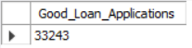
GOOD LOAN FUNDED AMOUNT –
SELECT SUM(loan_amount) AS Good_Loan_Funded_Amount FROM bank_loan_db.bank_loan_data WHERE loan_status = "Fully Paid" OR loan_status ="Current"
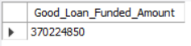
GOOD LOAN RECEIVED AMOUNT –
SELECT SUM(total_payment) AS Good_Loan_Received_Amount FROM bank_loan_db.bank_loan_data WHERE loan_status = "Fully Paid" OR loan_status ="Current"
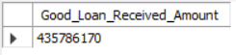
BAD LOAN PERCENTAGE (Charged Off) –
SELECT (COUNT(CASE WHEN loan_status = "Charged Off" THEN id END)*100)/COUNT(id) AS Bad_Loan_percentage From bank_loan_db.bank_loan_data;
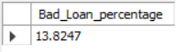
BAD LOAN APPLICATIONS –
SELECT (COUNT(CASE WHEN loan_status ="Charged Off" THEN id END)) AS Bad_Loan_Applications FROM bank_loan_db.bank_loan_data;
OR
SELECT COUNT(id) AS Bad_Loan_Applications FROM bank_loan_db.bank_loan_data WHERE loan_status = "Charged Off"
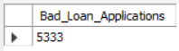
BAD LOAN FUNDED AMOUNT –
SELECT SUM(loan_amount) AS Bad_Loan_Funded_Amount FROM bank_loan_db.bank_loan_data WHERE loan_status = "Charged Off"
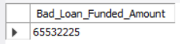
BAD LOAN RECEIVED AMOUNT –
SELECT SUM(total_payment) AS Bad_Loan_Received_Amount FROM bank_loan_db.bank_loan_data WHERE loan_status = "Charged Off"
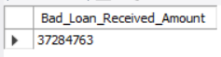

LOAN STATUS –
SELECT
loan_status,
COUNT(id) AS Total_Loan_applications,
SUM(total_payment) AS Total_Amount_Received,
SUM(loan_amount) AS Total_Funded_Amount,
AVG(int_rate * 100) AS Interest_Rate,
AVG(dti * 100) AS DTI
FROM
bank_loan_db.bank_loan_data
GROUP BY
loan_status
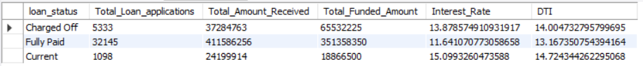
MTD LOAN STATUS –

SELECT
loan_status,
SUM(total_payment) AS MTD_Total_Amount_Received,
SUM(loan_amount) AS MTD_Total_Funded_Amount
FROM
bank_loan_db.bank_loan_data
WHERE
MONTH(issue_date) = 12
GROUP BY
loan_status
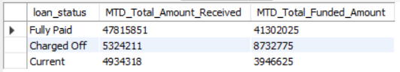

DASHBOARD 2 (OVERVIEW) –
MONTH TRENDS BY ISSUE DATE -
SELECT
MONTHNAME(issue_date) AS Month_Name,
COUNT(id) AS Total_Loan_Applications,
SUM(loan_amount) AS Total_Funded_Amount,
SUM(total_payment) AS Total_Received_Amount
FROM
bank_loan_db.bank_loan_data
GROUP BY
MONTHNAME(issue_date)
ORDER BY
MONTHNAME(issue_date)

OR (TO GET MONTH WISE)

SELECT
MONTH(issue_date) AS Month_Number,
MONTHNAME(issue_date) AS Month_Name,
COUNT(id) AS Total_Loan_Applications,
SUM(loan_amount) AS Total_Funded_Amount,
SUM(total_payment) AS Total_Received_Amount
FROM
bank_loan_db.bank_loan_data
GROUP BY
MONTH(issue_date), MONTHNAME(issue_date)
ORDER BY
MONTH(issue_date)
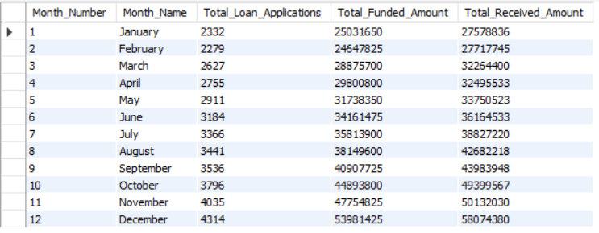
REGIONAL ANALYSIS BY STATE –
SELECT
address_state,
COUNT(id) AS Total_Loan_Applications,
SUM(loan_amount) AS Total_Funded_Amount,
SUM(total_payment) AS Total_Received_Amount
FROM
bank_loan_db.bank_loan_data
GROUP BY
address_state
ORDER BY
SUM(loan_amount) DESC
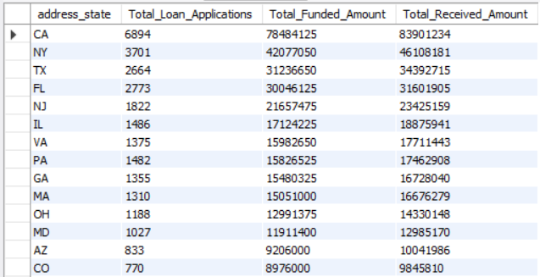

LOAN TERM ANALYSIS –
SELECT
term,
COUNT(id) AS Total_Loan_Applications,
SUM(loan_amount) AS Total_Funded_Amount,
SUM(total_payment) AS Total_Received_Amount
FROM
bank_loan_db.bank_loan_data
GROUP BY
Term
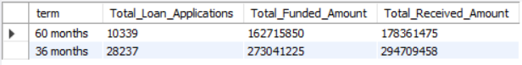
EMPLOYEE LENGTH ANALYSIS –
SELECT
emp_length,
COUNT(id) AS Total_Loan_Applications,
SUM(loan_amount) AS Total_Funded_Amount,
SUM(total_payment) AS Total_Received_Amount
FROM
bank_loan_db.bank_loan_data
GROUP BY
emp_length
ORDER BY
COUNT(id) DESC
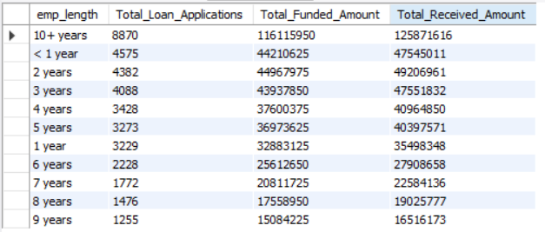
LOAN PURPOSE BREAKDOWN –
SELECT
purpose,
COUNT(id) AS Total_Loan_Applications,
SUM(loan_amount) AS Total_Funded_Amount,
SUM(total_payment) AS Total_Received_Amount
FROM
bank_loan_db.bank_loan_data
GROUP BY
purpose
ORDER BY
COUNT(id) DESC
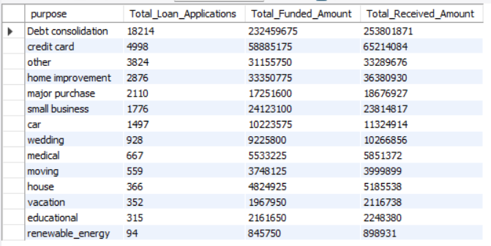
HOME OWNERSHIP ANALYSIS –
SELECT
home_ownership,
COUNT(id) AS Total_Loan_Applications,
SUM(loan_amount) AS Total_Funded_Amount,
SUM(total_payment) AS Total_Received_Amount
FROM
bank_loan_db.bank_loan_data
GROUP BY
home_ownership
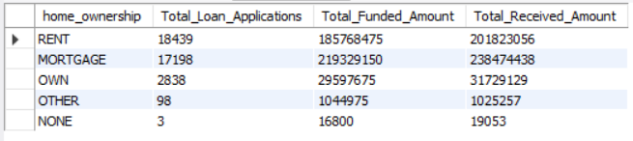

OR (To Classify by Grade)

SELECT
home_ownership,
COUNT(id) AS Total_Loan_Applications,
SUM(loan_amount) AS Total_Funded_Amount,
SUM(total_payment) AS Total_Received_Amount
FROM
bank_loan_db.bank_loan_data
WHERE
grade = ‘A’
GROUP BY
home_ownership
ORDER BY
COUNT(id) DESC
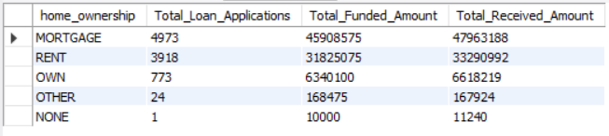
OR (To Classify by Grade and Address State)

SELECT
home_ownership,
COUNT(id) AS Total_Loan_Applications,
SUM(loan_amount) AS Total_Funded_Amount,
SUM(total_payment) AS Total_Received_Am ount
FROM
bank_loan_db.bank_loan_data
WHERE
grade = ‘A’ AND address_state = ‘CA’
GROUP BY
home_ownership
ORDER BY
COUNT(id) DESC
